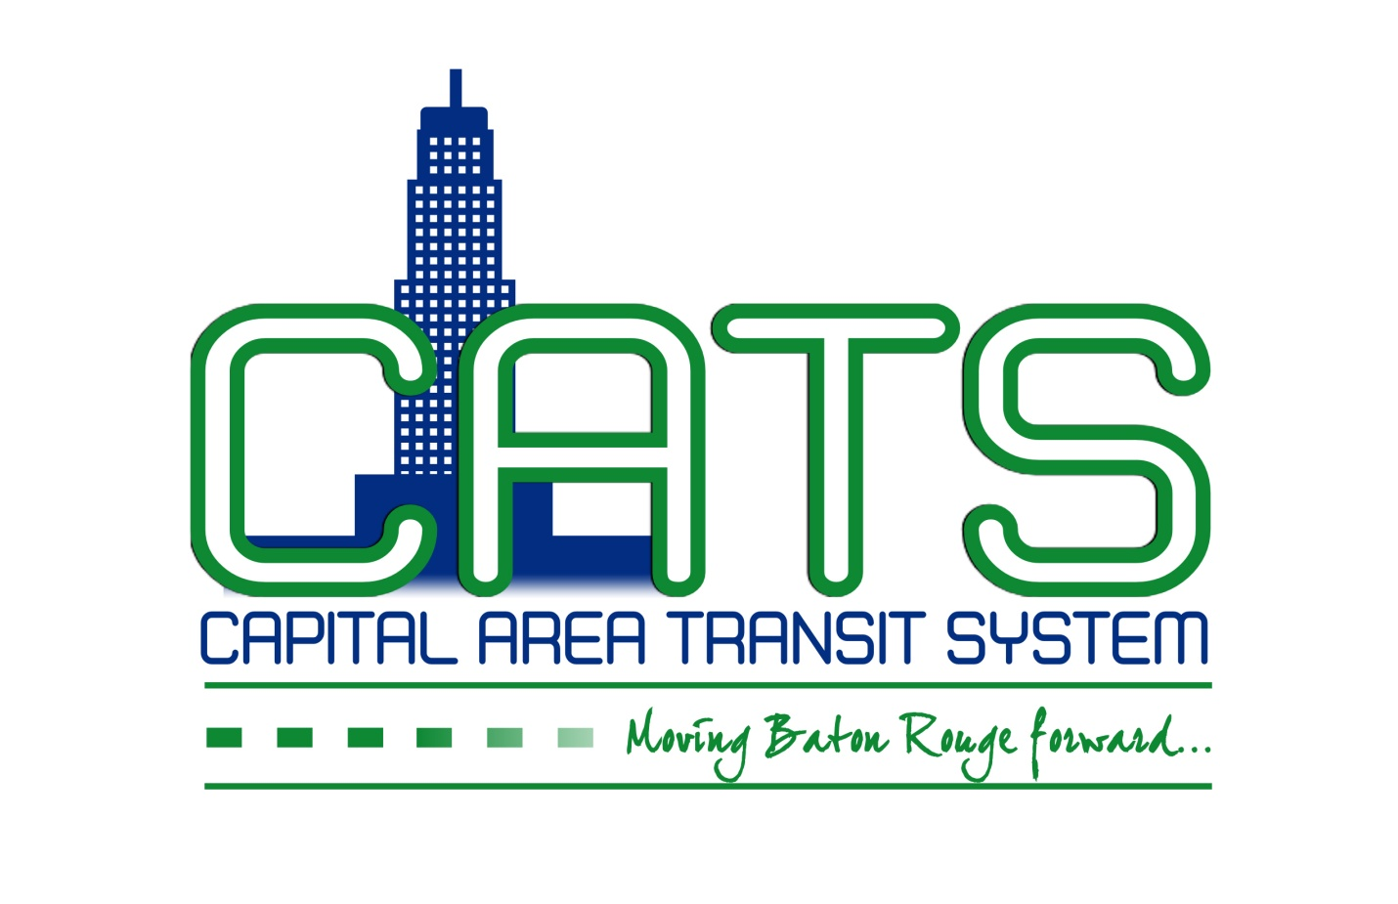
NOTICE OF CAPITAL AREA TRANSIT SYSTEM
PLANNING COMMITTEE MEETING
July 14, 2017
11:00 a.m.
Capital Area Transit System
5700 Florida Boulevard
Ninth Floor Conference Room
Baton Rouge, LA

AGENDA

Please take notice that the Capital Area Transit System Planning Committee will meet at CATS on Friday, July 14, 2017, at 11:00 a.m.

I. Continued discussion of organizational strategic plan and goals – Strategic Capital Improvements and Investments

Individuals needing special accommodations during this meeting should contact Karen Denman (225) 389-8920, Ext. 325, 2250 Florida Boulevard, Baton Rouge, LA 70802, no later than 4:00 p.m. on the Thursday immediately preceding the Friday meeting.

