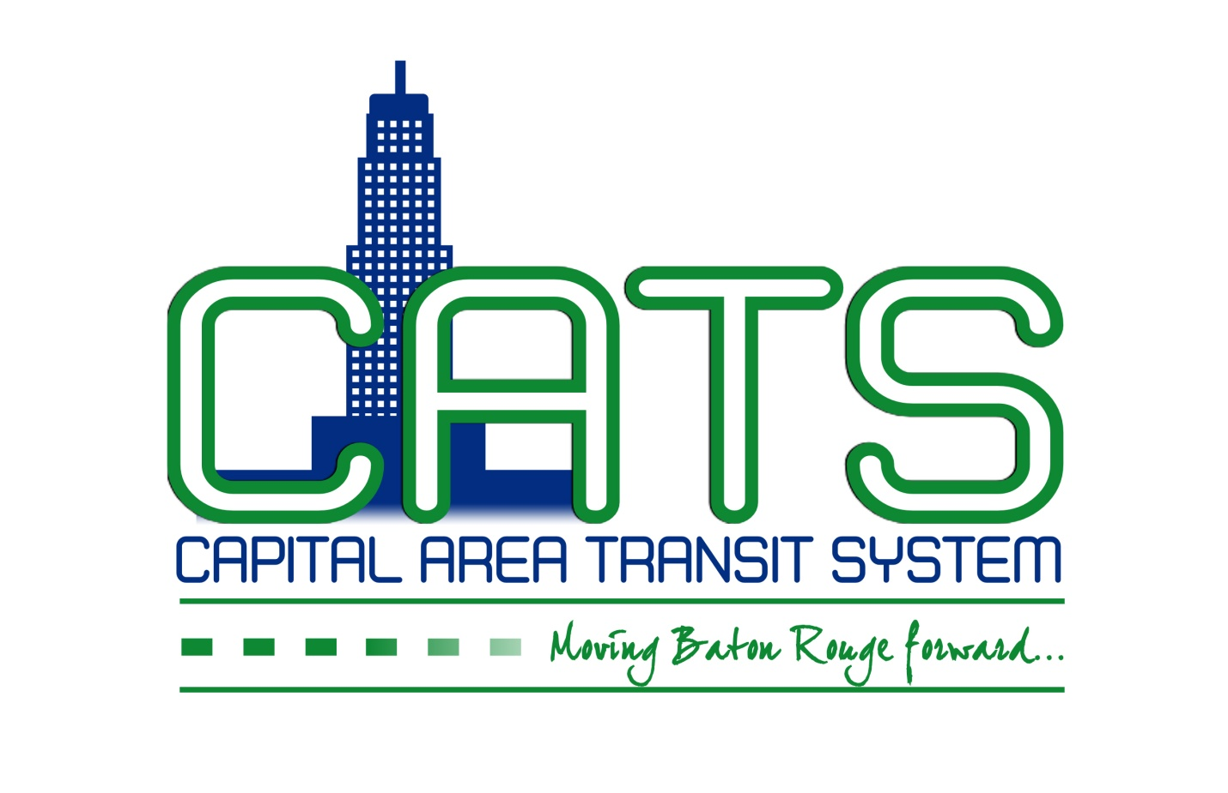
NOTICE OF CAPITAL AREA TRANSIT SYSTEM
FINANCE AND EXECUTIVE COMMITTEE MEETING
July 13 2017
10:30 a.m.
5700 Florida Boulevard,
Fifth Floor Conference Room
Baton Rouge, LA 70806

AGENDA

Please take notice that the Capital Area Transit System Finance and Executive Committee will meet in the fifth floor conference room at 5700 Florida Boulevard in Baton Rouge, LA, on Thursday,
July 13, 2017, at 10:30 a.m.

I. Call to Order and Establishment of Quorum

II. President’s Announcements

III. Executive Report

IV. Review of Financial Statements

V. Recommend approval of Public Participation Policy for FTA

VI. Recommend approval to award tire contract to Bridgestone Americas Tire Operations, LLC

VII. Recommend approval of HWA contract extension

VII. Discussion of organizational strategic plan and goals – Financial Responsibility, Accountability and Stewardship

Individuals needing special accommodations during this meeting should contact Karen Denman (225) 346-5557, 2250 Florida Boulevard, Baton Rouge, LA 70802, no later than 9:00 a.m. on the Wednesday immediately preceding the Thursday meeting.

