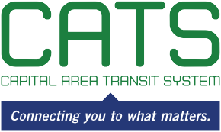

NOTICE OF CAPITAL AREA TRANSIT SYSTEM
FINANCE AND EXECUTIVE COMMITTEE MEETING
MAY 13, 2021
10:30 a.m.
Virtually and at
350 North Donmoor Avenue
Baton Rouge, LA 70806

AGENDA
Please take notice that the Capital Area Transit System Finance and Executive Committee will meet virtually and at 350 North Donmoor Avenue in Baton Rouge, LA, on Thursday, May 13, 2021, at 10:30 a.m.

I. Call to Order and Establishment of Quorum

II. President’s Announcements

III. Executive Report and Financials

IV. Recommend approval of HNTB Task 3-Comprehensive Operational Analysis

V. Recommend approval of Atlas Technical Consultants Task Order 2–18-month extension

VI. Recommend approval of updating the HVAC System at 2250

VII. Recommend authorization of tax elections for Capital Area Transit System

Individuals having questions regarding the meeting should contact Theo Richards, 225.389.8920, 2250 Florida Boulevard, Baton Rouge, LA 70802.

Individuals needing special accommodations during this meeting should contact Karen Denman (225) 346-5557, 2250 Florida Boulevard, Baton Rouge, LA 70802, no later than 9:00 a.m. on the Wednesday immediately preceding the Thursday meeting.

