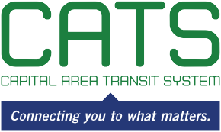

NOTICE OF CAPITAL AREA TRANSIT SYSTEM
AUDIT COMMITTEE MEETING

May 13, 2021
1:00 p.m.
350 North Donmoor Avenue
Baton Rouge, LA

AGENDA

Please take notice that the Capital Area Transit System Audit Committee will meet in the 350 North Donmoor Avenue in Baton Rouge, LA, on Thursday, May 13, 2021, at 1:00 p.m.

- Review 2021 Budget

- Review 2020 Audit Status & Findings

Individuals needing special accommodations during this meeting should contact Karen Denman (225) 346.5557, 2250 Florida Boulevard, Baton Rouge, LA 70802, no later than 4:00 p.m. on the Friday immediately preceding the Monday meeting.

