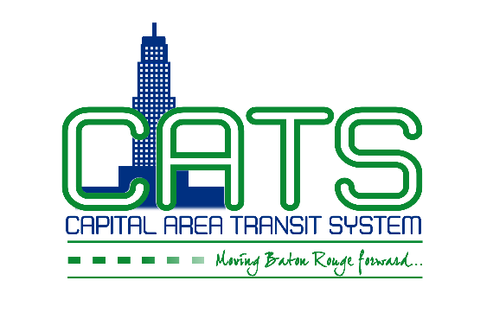
JOB ALERT:
Effective March 26, 2015

Auto Mechanic I
MINIMUM QUALIFICATIONS:
- High School Diploma or equivalent.
- Three years of experience as a vehicle mechanic in any area.
- Valid Louisiana Commercial Driver’s License with ability to obtain Passenger endorsement.
- Knowledge of vehicle mechanics, including but not limited to: diesel and gasoline engines, mechanical, electrical, hydraulic and pneumatic systems.
- Ability to independently or with minimal assistance provide repair service to engine and all mechanical parts of a bus or vehicle.
- Must be able to read, interpret and follow repair and installation instructions; perform repair and maintenance timely as assigned by Supervisors and Managers and must maintain required schedule
- Resume preferred
- Full-time employment
- Hours: Varies
- Background Check, Drug Screen and Confidentiality Agreement Required

